## I.Introduction of project products

It is human nature to love beauty. In view of this feature, we launched the app "Meitu 3D" to solve the needs of the majority of users. "Meitu 3D" app is mainly divided into beauty, fitness, wear and match three sections, in a three-dimensional way, so that users feel a full range of beautiful experience.

## **Ⅱ.Requirements Specification**

Nowadays, with the rapid development of The Times, people pay attention to the changes of their appearance, which also produce a huge demand. According to the survey, more than 78% of people have the needs of beauty makeup, clothing, fitness and other aspects in their daily life (as shown in Figure 2-1), which has even become the daily

necessities of contemporary young people. Women are more willing to use makeup to improve their facial appearance, while men are more willing to use fitness to beautify their

body. People often rely on clothes to enhance their fashion, but also use them to improve

their body shape.

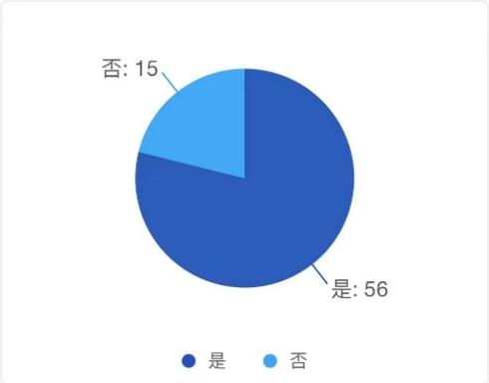

Figure 2-1 Whether there is a need for beauty, clothing, fitness, etc

**1. Beauty**

Makeup has become a necessity for most women and some men. Many people rely on makeup to achieve beauty in their daily lives, as well as to achieve a dignified effect in formal situations. For most of us, beauty is a skill we develop later in life. Many people will encounter problems such as stepping on the trap, product recommendations and so on, systematic makeup tutorials and high-quality makeup product recommendations become an indispensable part of the process.

1. **Fitness**

There is a growing need for men to manage their bodies. Both male fitness groups and many potential female customers have become the user target of this product. The fitness program not only targets at those who need physical exercise, but also includes many users who live a healthy life. The system of fitness tutorial and arrangement can avoid the user in the face of the multifarious tutorials on the market produced visual fatigue, but also eliminate the market of invisible consumption brought by the trap.

1. **Wear and match**

At present, with the rise of fashion consciousness, it has once become a development hotspot. People pay more and more attention to the personalized expression of personal

image. As an important way of image building and publicity, clothing and related industries are booming under the wide attention. However, there are quite a large number of groups are troubled by clothing collocation, such as the idea of wearing confused, wearing a single style, collocation effect is not satisfied, clothing idle rate is high. Although there are a lot of clothing matching software or APP products on the market, there are various limitations of intelligence, and most of the consumerism bound people impulse consumption, it is difficult to provide users with professional and scientific wearing services.

This APP is based on users, aiming at the pain points of the needs of the majority of users, so as to really solve the problems of users, but also solve the drawbacks existing in the market at present. This product is based on the market gap and huge demand gap, grasp the target users and potential users, suitable for the market.

## **Ⅲ.Overall Design**

**1. Beauty section**

Users can use "Meitu 3D", through graphic videos and other forms, at any time to learn beauty knowledge, correct some wrong beauty practices. How to use hundreds of cosmetics, and how to make up for different skin and face shapes can all be answered by this APP. At the same time, Meitu 3D will regularly release cosmetics-related texts, so that users can learn how to choose various cosmetics suitable for them while reading them, so that they will not be fooled by shopping guides in shopping malls. The most outstanding feature of "Meitu 3D" is its strong pertinent. users can click on the facial features of the interactive face to view the makeup in different areas, but also can choose different styles of makeup through the navigation bar, filter out invalid information, greatly improve the search efficiency, to provide accurate answers for customer needs.

**2. Body building section**

The function developed by "Meitu 3D" fitness section has articles and videos related to fitness teaching. According to different parts and users' different needs, "Meitu 3D" will provide training and teaching videos with different functions and strengths. In addition, there is a special section in the fitness section. According to the characteristics of people who keep fit and lose weight, a wealth of thematic content is recommended, including training videos, music library, action library and diet topics, to help users develop fitness recipes.

**3. Wear the plate**

"Meitu 3D" wear plate is very practical, very powerful, here brings together a lot of clothing collocation case, you can view at any time, but also according to the weather and user's own situation own situation to give advice on dressing, to help users easily walk in the forefront of fashion!

## **Ⅳ.User Interface Design**

1. **Login interface**

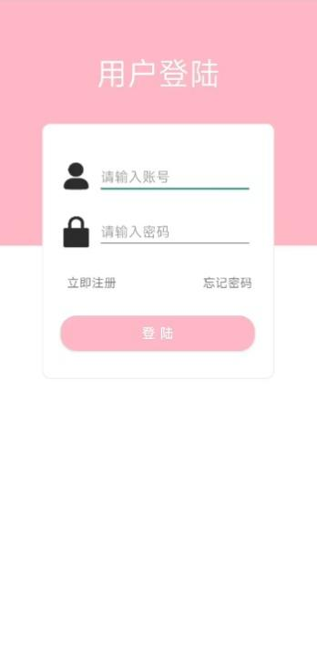

Users can register and log in through the login interface. This interface has two text boxes and a login button. Users can register their accounts on this interface and then return to this interface to log in.

1. **Home and Discovery Pages**

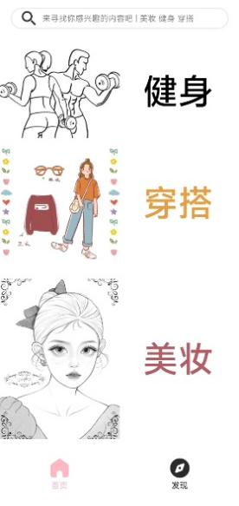 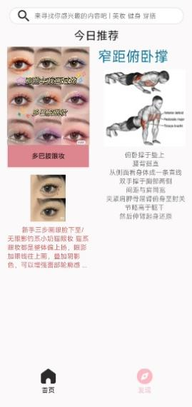

The homepage interface is divided into three sections: beauty, dressing, and fitness. You can click on the section you are interested in to obtain more relevant information.

In the discovery interface, you can browse any content you are interested in, which will appear in your discovery exploration based on your preferences and today's hot topics.

1. **Beauty section**

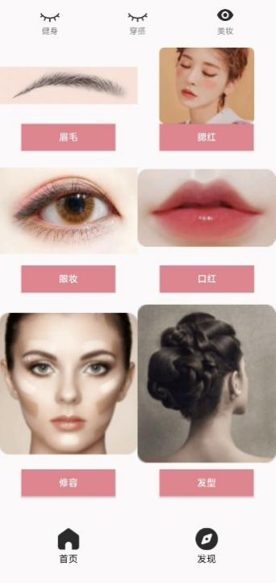 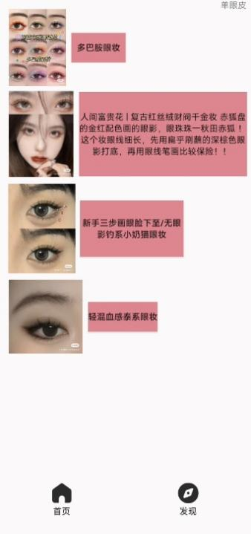 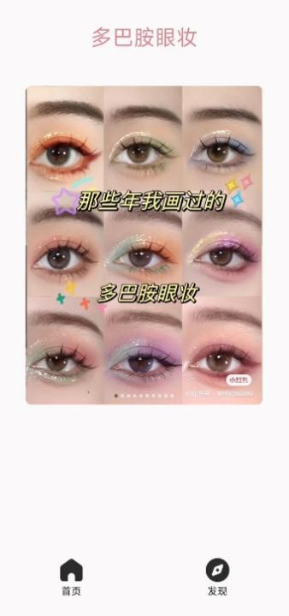

Within the beauty section, it is divided into a sub section where users can selectively choose the section they want to refer to and learn from, basically covering all the needs for beauty.

After entering the section, you can view the corresponding specific content. We will select the tutorials that we think are most helpful and attach the sources to provide users with the most practical assistance.

At the same time, in the segmentation page, users can also further choose different classifications that are more detailed.

1. **Fitness section**

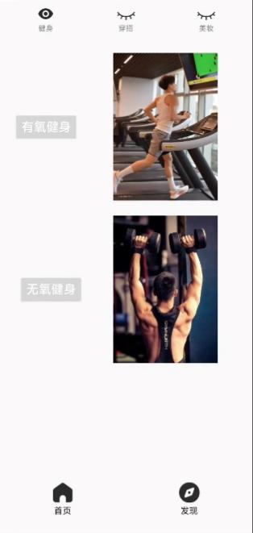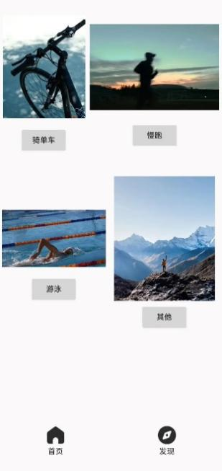

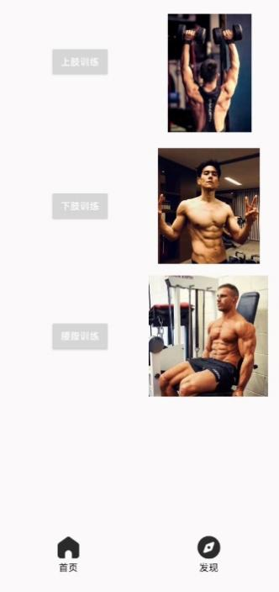 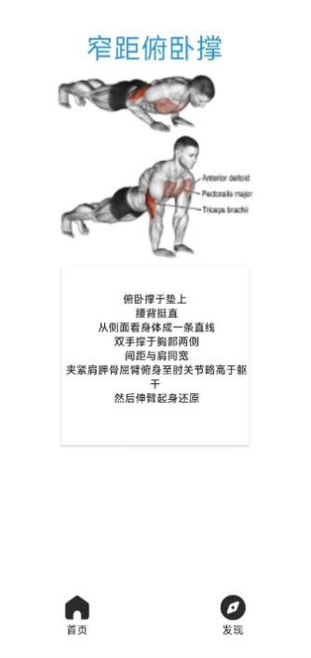

The fitness homepage is mainly divided into two parts: aerobic fitness and anaerobic fitness. Users can jump to the aerobic fitness or anaerobic fitness page by clicking the button or image.

The upper body section is mainly composed of four categories - cycling, jogging, swimming, and other aerobic activities.

Users can click on different classification buttons based on their own situation and different needs to search for the information they want.

The anaerobic fitness section is mainly divided into three parts - upper limb training, lower limb training, and waist and abdomen training. Similar to the aerobic fitness section, users can click on buttons or images according to their different needs to jump to various fitness consultation teaching.

1. **Overlay plate**

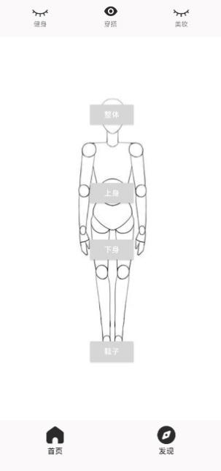 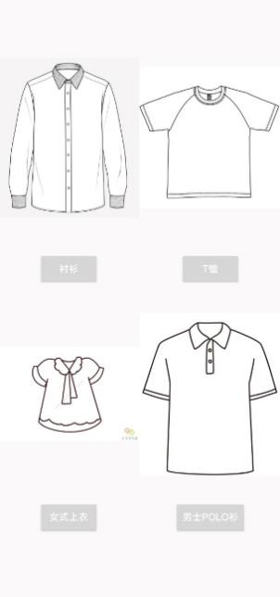 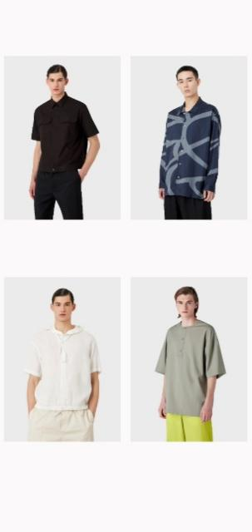

The clothing homepage is mainly composed of Mannequin. Users can click on different parts of the body to realize the jump of different parts.

Users can jump to the four sub pages of "Overall", "Upper Body", "Lower Body", and "Shoes" according to their own needs, in order to obtain more information that users need.

The upper body section is mainly composed of four categories - "shirt", "T-shirt", "women's top", and "men's POLO shirt".

Users can click on different classification buttons based on their own situation and different needs to search for the information they want.

The lower body section is divided into two categories based on gender differences and user preferences, namely "pants" and "skirts".

These two categories are currently two mainstream trends in the market regarding lower body wear, and users can easily and quickly navigate to their desired clothing recommendations based on this classification.

In the shoe sector, we have also adopted two classifications, namely sneakers and high heels. These two categories are in line with the current mainstream trend of gender segmentation, and we will also add more types for users to choose from in the future.

The overall section is divided into two categories: men's and women's, targeting the needs of users who require full body dressing recommendations.

For users who need full body recommendations, the overall section can help users reduce their own pairing troubles, and also provide more coordinated and systematic recommendations for suitable clothing combinations.

## **Ⅴ.Key Technologies**

**1. During the development process, a login interface was added for the App, and users need to enter their account and password for authentication. The following are the main technical and technical challenges faced during the development process:**

User authentication and authorization: In order to realize the user login function, it is necessary to design and implement the user authentication and authorization mechanism. This includes verifying that the account and password provided by the user match and assigning the appropriate permissions and access levels to the authenticated user.

User interface design: The login interface is the entry point for users to interact with the App, so it is necessary to design an intuitive, easy to use and attractive interface. This includes choosing appropriate colors, fonts, and layouts, as well as providing friendly error prompts and help messages.

**2. In the development process, information collection updates will require databases to store and manage data in the future. The following are the main technical and technical challenges faced during the development process:**

Database design: In order to efficiently store and manage large amounts of user data, we need to design a suitable database structure. This includes determining how data tables are organized, defining fields and relationships, and choosing the appropriate database management system (such as MySQL, Oracle, and so on).

Data model design: A data model is a logical representation of data in a database that describes the relationships and constraints between the data. During the development process, the data model needs to be designed and defined to ensure the consistency, integrity and accuracy of the data.

Database query and optimization: As the amount of data increases, the performance and efficiency of database queries becomes particularly important. We need to optimize database queries, using indexes, caching, and other techniques to improve query speed and response time.

Through the rational design and management of the database, the "Meitu 3D" application can efficiently store and manage user data, and provide stable and reliable information collection and update functions.

## **Ⅵ.Testing and User Experience Analysis**

This test used Firebase Test Lab for Android to perform various tests on the Meitu 3D app, including automated testing, compatibility testing, and performance testing. The purpose of the test was to evaluate the compatibility, stability, and performance of the application on different devices and operating systems, and to identify any potential issues and provide solutions for improvement.



**1. Automated Testing**

In this test, the application passed Robo testing on 90% of the devices and operating systems, and successfully completed UI operations in 90% of the test steps. However, in 10% of the test steps, some UI elements had errors, such as certain buttons being unclickable or page layouts being misplaced.

**2. Compatibility Testing**

In this test, the application ran well on 83% of the devices and operating systems, but experienced crashes or lagging on 17% of the devices and operating systems. In particular, the application's compatibility performance was poor on some devices with Android 8.0 and below, frequently experiencing crashes.

**3. Performance Testing**

In this test, the application had an average startup time of 2.3 seconds, an average response time of 1.2 seconds, and a maximum memory usage of 250MB. However, in some cases, the application experienced significant lagging, with response times exceeding 3 seconds and memory usage exceeding 400MB.

**4. Crash Testing**

In this test, the application had an average startup time of 2.3 seconds, an average response time of 1.2 seconds, and a maximum memory usage of 250MB. However, in some cases, the application experienced significant lagging, with response times exceeding 3 seconds and memory usage exceeding 400MB.

**5. User experience**

**a) User preference**

In most groups where there is a need for beauty, fitness, clothing, etc., people are more

willing and need some tutorials to help them improve themselves. According to the survey, 70% of people need some systematic materials to help them (see Figure 3-1). The tutorial arrangement of this product system is in line with the majority of users' preferences.

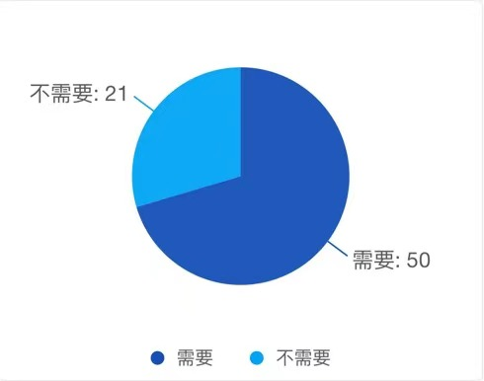

Figure 3-1 Whether a tutorial is needed

**b) User acceptance**

In fact, most users are willing to accept the birth of apps such as this product while they

need the help of tutorials. According to the survey results, more than 78% of them are willing to accept and use apps of this product type (see Figure 3-2). At the same time, it also shows that this product has a certain degree of user acceptance in the market, and there is a good development market.

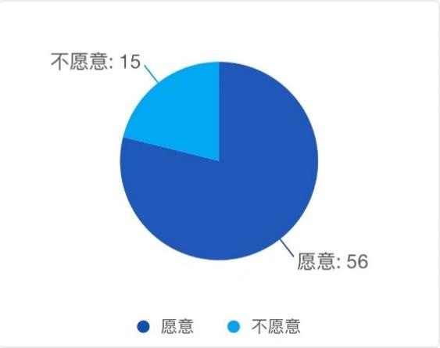

Figure 3-2 Whether this type of APP is accepted

## **Ⅶ.Conclusion**

In conclusion, our team successfully completed the Android Studio App design project, achieving our goals of creating a user-friendly, functional, and visually appealing App.

During the design process of this App, our team faced many challenges, but we successfully completed the task and gained a lot of valuable experience and skills. **Here is our summary:**

**Teamwork:** Our team consisted of members from different backgrounds and fields, but we showed excellent teamwork throughout the entire project. We learned how to effectively allocate tasks and support each other to ensure the project was completed on time.

**Technical skills:** In this project, we learned many new technologies such as Android Studio, Java programming language, XML programming, etc. We also learned how to use version control tools (such as Git) to coordinate our work. These skills will be very useful for our future career development.

**User experience:** Our team paid great attention to user experience and worked to improve it throughout the project. Through user testing and feedback, we constantly improved our App to ensure it was easy to use, powerful, and user-friendly.

**Project management:** We used agile development methods throughout the project to ensure we completed tasks on time and met the client's requirements. We held regular meetings to discuss the project's progress and issues, and adjusted our plans in a timely manner.

**Deliverables:** Our team's App was designed based on a business model and provided useful features for users. We created a beautiful UI for the App and provided easy navigation. Most importantly, our App received high praise during the presentation.

Our team gained a lot of valuable experience in this project and learned how to effectively collaborate, utilize new technologies, focus on user experience, manage projects, and showcase deliverables.

**During the development process,** we faced several challenges, such as ensuring compatibility across various devices and addressing user feedback. However, we overcame these challenges by adopting agile development methods, regularly communicating with each other, and remaining focused on our goals.

**Moving forward,** we have several improvement plans for our App. Firstly, we need to further enhance its aesthetics, practicality, and compatibility aspects. Secondly, we should focus on addressing the issues raised by users in their feedback. These include:

1. Increasing content diversity to cover various useful information across different categories.
2. Enhancing the practicality of the content by regularly updating the system with the latest information and removing outdated content.
3. Improving the system functionality by adding a browsing history feature.
4. Diversifying the search function to help users locate useful information more quickly.
5. Offering a range of information presentation formats, including videos, images, and text, to better meet the diverse needs of users.

In summary, we will continue to collect user feedback and make further improvements to our App based on their needs.

Overall, we are proud of our achievements and confident that the skills and experience we gained from this project will be valuable for our future careers.